**OOAD Assignment 4**

Jonathan D’penha

PRN: 23030142005

**Scenario**:A web site to buy books (hard copy and soft copy).

For assumed case study do following:

1. **Identify and explain the various scenario for the selected case study**
2. **User Registration/Login:**

* User wants to register on the website to buy books.
* They may have the option to register through email, social media, or a guest checkout feature.
* After registration, they can manage their account details, including shipping addresses, payment methods, and order history.
* User wants to log in to access their account.

1. **Browsing Books:**

* User wants to search for books by title, author, genre, etc.
* Genres such as fiction, non-fiction, best sellers, etc.
* User wants to view details and prices of the books.
* User wants to filter books by criteria such as price range, popularity, release date, etc.

1. **Adding to Cart and Checkout**

* Users can add books to their shopping cart.
* They can view their cart to review the items they've selected and adjust quantities if necessary.
* Proceeding to check out, they enter shipping details and select a preferred shipping method.
* They choose a payment method (credit/debit card, PayPal, etc.) and complete the transaction.

1. **Leave a Review**

* After purchasing and reading a book, the user decides to leave a review.
* They navigate to the book's page and find the review section.
* They rate the book (usually on a scale of 1 to 5 stars) and write a brief review sharing their thoughts, opinions, and recommendations.
* Once submitted, their review is displayed on the book's page for other users to see.

1. **Order Tracking and Delivery**

* After placing an order, users receive a confirmation email with order details.
* They can track the status of their order through their account dashboard.
* Once the order is shipped, they receive a tracking number to monitor the delivery progress.
* Upon delivery, users confirm receipt of the books and may have the option to provide feedback or rate the service.

1. **Return Order**

* Users may encounter issues such as damaged books, incorrect orders, or inquiries about their orders.
* They can contact customer support through various channels such as email, live chat, or a dedicated helpline.
* The website should have a clear returns and refund policy outlining the process for returning books and receiving refunds or replacements.

1. **Draw a Use case diagram**

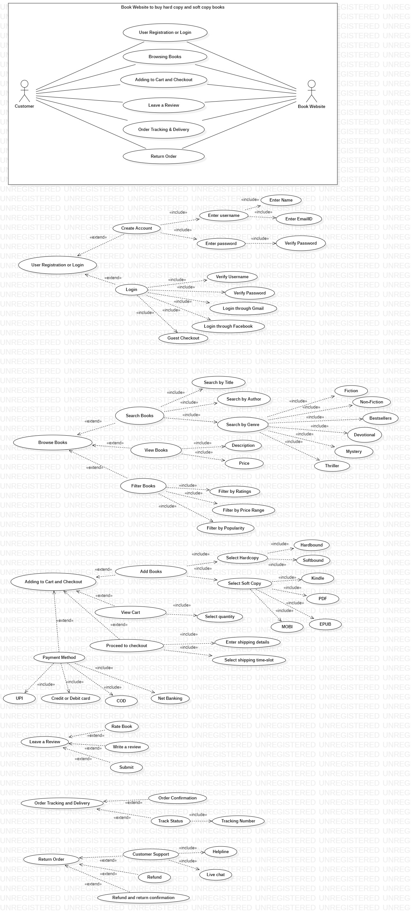

1. **Draw a class diagram**

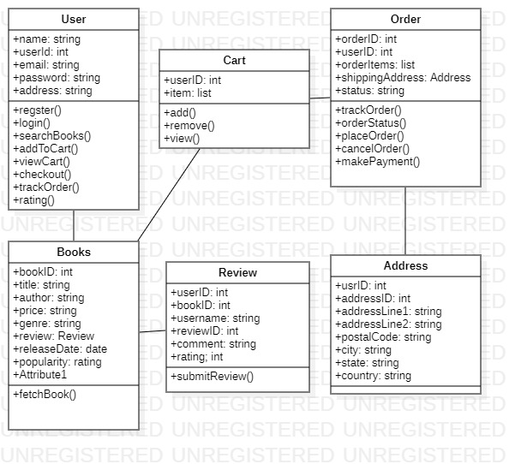

1. **Draw a sequence diagram**

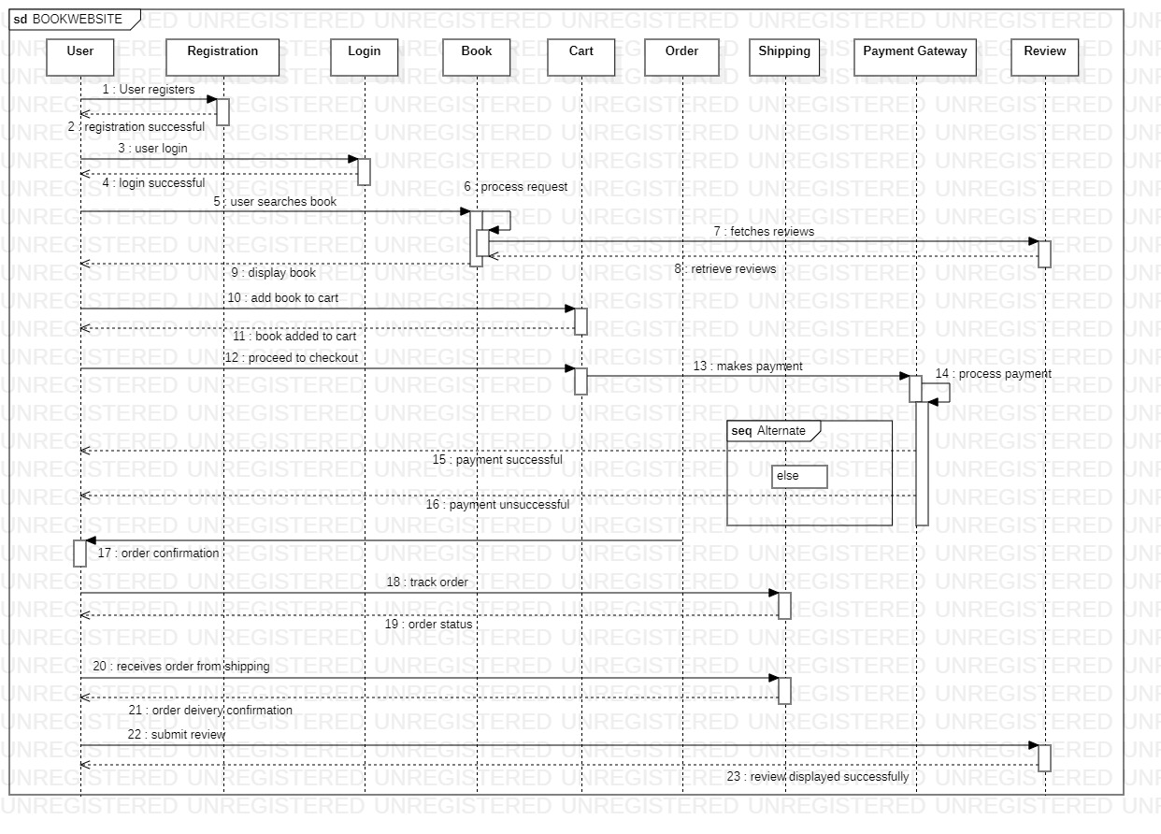

1. **Draw a communication diagram**

